Mobile Application Proposal

Mobile Platform Applications ITEC31041
Elliot Harding(N0688119)

Contents

1. Executive Summary............................................................................... 2
2. Mobile Software and Hardware Development options.................................. 2
3. Usability and Guidelines.......................................................................... 3
4. Requirements and Constraints................................................................. 4
5. Proposed Idea and Impact...................................................................... 6
6. App Features........................................................................................ 7
7. Evaluation of Paper prototype................................................................. 8
8. Appendices:
8.1 Personas................................................................................... 9
8.2 Paper prototype........................................................................ 10
9. Bibliography....................................................................................... 24

- Executive Summary

Food apps

Thanks to mobile innovation and the increasing availability of internet access the current food-app industry is a booming success. Examples of successful food apps include; Uber eats, Deliveroo and Just-Eat to name a few. In 2018 Just-Eat processed over 221 million orders (Statista, 2018). From these facts one can deduce a large demand for food delivery via mobile apps.

Issues with current food apps

Most of these apps use restaurants and takeaways for their food sources. As seen above, while very successful, prices tend to be high and users tend to favour large brands removing the sense of community which food should bring.

Home cooks who want to make their name as a chef, chefs wanting to bond over food, or people who wish to make some additional income selling food cannot make use of these apps without setting up their own takeaway. This is where Menu (Me n’ U) comes in.

Proposed solution

The Menu app allows users to run their own takeaway/restaurant from their own kitchens. The app has two types of users; Chefs, and eaters. Chefs sell food made in their kitchen to eaters. Food can be either sold as takeaway or eaters can eat in chefs’ kitchens.

The Menu app has many target audiences;
- People looking for a cheaper alternative to takeaway meals, while keeping the same quality and delivery time of food
- Aspiring chefs looking for cooking experience and feedback on their work
- People wanting to easily make some additional income through cooking
- People looking to bond over food

Overview

The rest of this document will outline the development choices, features, and impact of the app. This will be to demonstrate the worthiness of the app in addition to how it would be developed (and why), if it were to be invested in.

- Software and Hardware Development options

Mobile hardware

Phones offer a range of additional capabilities that other hardware platforms cannot offer. Of these the primary is portability thanks to their size and lack of need for an external power supply. This will come in handy for the app being developed, since users will be moving around. Phones tend to also be cheaper than alternative devices to run applications such as laptops or desktop computers.
Applications developed on mobiles also have access to phones hardware which offers a range of useful tools to be used. For example, GPS, Bluetooth, NFC, proximity sensors etc… Many of which will be used by the app.

Mobile software
Of all the mobile operating systems (OS) within the current market, Android, Windows Phone and IOS (Apples OS for iPhones) are the main competitors.
Google’s Android operating system runs on a range of hardware models, including Smart TV’s, tablets, and phones. This is not the case for IOS and Windows phones in which their OS runs on a specific set of phones. This limits the choices users have in what they want out of a device.
Android is a good choice when creating an initial app due to the close to free development costs associated with it. Phones run using various distributions of the OS. The base OS is open source and runs software applications in the form of APKs (Android application package). This is not the case with IOS (Apples operating system for iPhones) which comes with various restrictions and costs in terms of how the app is developed, for instance the requirement of an apple device for development, or the 90$ yearly cost of putting the app on the store. While free to develop on, windows phone also has costs associated with the releasing of apps. Windows phone operating systems are also not open source meaning a windows phone would be required for development.
Targeting app development towards android phones expands the available target audience due to the vastness of its usage. Over 76% of mobile phones currently run android as an operating system (gs.statcounter.com, 2019). As of May 2019, there are now over 2.5 billion active android mobile devices (The Verge, 2019).
As a result of the points above, the app will initially be developed for the Android OS.

- Usability and Guidelines

Considering android is a google product, choosing the google design styles (Google, 2019) for android made sense, since the design style is tailored for the products in which the app will run. The app will also make use of google maps, which further solidifies the idea of using the google design styles, since they are from the same company.

In terms of colours, the google design styles suggest using:
- A primary colour with dark and light variants
- A secondary colour, also with dark and light variants, which compliments the primary
- And sparing use of surface, background and error colours

Colour choices

Primary variants



Background & surface

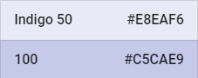
Secondary variants

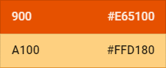

Error



Two variants of the primary colour allow contrast between UI elements, such as distinguishing a top app bar from a system bar, while keeping the same overall theme consistent.
A secondary colour provides more ways of distinguishing UI elements, the difference being the extent to which they are distinguished. This allows the user to tell apart different categories of UI elements represented by a primary and secondary variant, which contain sub categories represented by dark and light variants.
The chosen Surface & background colours as suggested by the google design style documentation have been selected as weak toned colours so as to not distract the user from more important UI elements.
In contrast, error colours tones have been chosen as bold colours, which draw users’ attention to important information. These colours do not compliment the primary and secondary colours to stand out.
The colours have been chosen with users with colour blindness in mind. Since the two main types of colour blindness are difficulty distinguishing between red and green, or between blue and yellow (Neitz, Maureen, 2007), these specific combinations have been avoided.
Thanks to Android’s configuration settings allowing users to scale text larger if needed, little consideration as to the size of the apps text is required. Therefore, text of the app will be designed to be legible for users without any text size vision impairments. Positioning of text however will need to account for the fact that the text may be scaled to maintain a clear appearance.
When it comes to layouts, Google’s android design styles suggest maintaining consistent UI regions and spatial organisation, along with having responsive and adaptive (to different screen sizes) UI elements. Therefore, all pages of the app will follow this style.

- Requirements and Constraints

Below are the outlined requirements of the application. To assure quality of the requirements they are ensured to be; correct, unambiguous, complete, consistent, ranked for importance, verifiable, modifiable, don’t specify any particular design and traceable. Rankings are done via the MoSCoW method (projectSmart, 2019) and include, must, should, could and would.

Functional requirements

1. The application must provide a method for chefs to advertise meals they are offering to cook to nearby customers. Information related to the meal should include it’s; name, ingredients, allergy/food-preferences categories, picture, price per dish, calories, time’s it is sold along with the location of the chef cooking the meal.

2. The application must provide a method for users to search for advertised meals which they can order. Search methods should involve a map and search bar which will be filtered by options selected by user. Filter options include; food type, allergy/food-preference related information and opening times.

3. The application must persistently store user, meal and order information within a database. This should update in real time for user interactions with the app. By keeping the database up to date all users are provided the most relevant to date information.

4. The application must show users the location of the chefs which cook the meals they search for. This provides a method for users to locate chefs’ kitchens as well as determine the proximity of the meal searched.

5. The application must allow users to edit their settings, information and meals. This means data is up to date and therefore users will be provided correct information.

6. The application should clearly display all errors which occur during its usage. This will aid the user in understanding any interruptions in terms of flow of processes, and if it’s a user error, imply a method of correcting the error.

7. The application should maintain a responsive UI. This includes during timely actions in which loading symbols could be displayed. By making the interface respond swiftly, there is a lessened chance that users will make an erroneous click in anticipation of the interface updating. Responsive interfaces are also preferred to users, as they provide them with a better flow in terms of interaction.

8. The application should provide users a basket in which their meals to be ordered are collected. This basket should then be able to be “Checked out”. Before checking out, the consumer should be able to add and remove products they have in their basket. Virtual baskets are used by most online retail sites which makes the system more relatable to consumers.

9. The application could provide a means of communication between users who are meeting chefs. This will attempt to circumnavigate any issues regarding time, delivery of food or users trying to find the location of chefs.

10. The application could store user’s location information. This would circumnavigate the issue of requiring GPS in order to use all the app’s features.

11. The application could provide a method for users to pay chefs for their meals. This provides an easier alternative to paying by cash for the food.

12. The application could show users if chefs are cooking meals to meet new people. This would allow users to match with chefs wanting to do the same thing.

Non-Functional requirements

1. The application should respond in a timely manner for user interface actions and database transactions. This will keep users engaged and make using the application worthwhile.

2. The application must be able support a large quantity of active and inactive users. Once the app is released the database may be subject to many interactions from different users simultaneously. The database must withstand these interactions without slowing down to maintain its service in a timely manner.

3. The application should encounter little to no errors during its usage. Lack of errors maintains the flow of the application, keeping users engaged as they won’t become frustrated with it. UI elements therefore will need to be laid out clearly to lessen the chance of users from making errors.

4. The application should clearly display information to users in an aesthetically pleasing manner and be consistent in the way it achieves this throughout. This will maintain user engagement and keep users happy due to the low cognitive load of consistency and clarity.

Constraints

Due to the requirement of a database in order to facilitate data storage and transactions, consistent maintenance of the server should be required. This however is not an issue thanks to the use of an external host of the server in which the database will run.

The app will require GPS permissions in order to use all its functions. This constrains users as to where they can use the app for it to fully function.

For any of the apps features to function a WIFI or mobile data connection is required due to its reliance on a database connection.

For users to be chefs, they will need to sign a disclaimer. Chefs will also need to be over the age of 18. This is because of legal issues arising as a result of the sale of food.

- Proposed Idea and Impact

Menu hits a unique point in the food industry market in which there is demand, there are currently very few applications which give users the ability to easily sell food from their own home, none of which run on mobiles.
Food prices (which will be set by users) are expected to be cheap. Thanks to these prices of food users are provided a cheap alternative to eating out while still receiving the same quality food a restaurant would provide, which should in-turn increase demand for the app.
Food has been proven as a very useful tool to promote bonding between primates (Roman M. Wittig et al. 2014). Considering this, the app would be a perfect fit for students as worrying about making friends, especially at the start of term, is one of the primary issue’s university students face. Even for users who are not students, the app still has the benefit of facilitating a means for people to meet, get together, and eat.
Thanks to the points above, both types of users (chefs and eaters) have strong incentives to use the app. This will hopefully encourage a large user base therefore generating a great deal of revenue.

6. App Features

Feature | For | In order to achieve
A secure login method | All users | Security of user’s information and identity.
Sign up | All users | Access to the app’s features for the user.
Remote hosted SQL database | All users | The transfer and storage of various data related to the app.
Database connection (Via PHP scripts) | All users | To provide connection between the app and database.
Navigation drawer | All users | Easy navigation between the different pages of the app.
Meal/chef search | Eaters.  Personas: Claire | A method for eaters to find food to order.
Interactive maps | Eaters.  Personas: Claire | A method for eaters to find food to order. Chefs will be located on the map, clicking on them navigate the user to a page displaying a list of the corresponding chef’s meals.
A facility to edit/add meals on sale | Chefs.  Personas: John | The adding/updating of meals by chefs to the database.
Settings editing | All users. | Up to date settings, therefore displaying the correct information. Also, to provide users with the ability to sign up as chefs.
A meals basket | Eaters.  Personas: Claire | The ability to order multiple meals at once.
Facilitation of payment | All users | The ability for eaters to pay chefs for their food.
Chat | All users | The ability for eaters and chefs to communicate their meetup to eat, weather takeaway or eating at the chefs.
Ratings of meal/chefs | All users | An assurance of food quality.

7. Evaluation of Paper prototype

Once the paper prototype was made, two people was asked to try it. Below is the feedback they gave, and what changes were made as a result.

Tester | Sam Milward
Comments
I like the idea of showing the location of the meals on the map. The navigation drawer is also a very nice addition to the app as I find it helps with flow around it. It seems odd to have the navigation drawer on one page only. Perhaps it would be worthwhile adding it to each of the pages in which it navigates to.

Changes
Added the navigation drawer to the pages; settings, basket and chef meals. In retrospect this makes a lot of sense and adds to the flow of the app.

Tester | Liam Franey
Comments
I like the fact that every feature within the application is designed with a purpose in mind that contributes to the overall goal of the project. In terms of improvement, perhaps it would be worthwhile showing the ‘my meals’ option on the navigation drawer for only chefs. Also, saving users card payment details seems worthwhile.

Changes
Noted that the ‘my meals’ option on the navigation drawer will only be displayed for chefs. Also added the ability to save a user’s card details, which improves ease of use and provides time saving.

- Appendices:

  - Personas

Since the app has two types of users; chefs and eaters, two corresponding personas have been made to demonstrate a use case for the user types.
  John  Age 29, works in administration | Behavioural demographic information  - Married  - Lives in London city centre  - Enjoys cooking as a pastime
Pain points & needs  - Wants to meet new people  - Aspires to become a chef  - Not receiving enough income from his main job | Potential solutions provided by app  - Provide a means for John to meet new people  - Provide a way for people to test out John’s meals and give feedback  - Provide John some extra cash to overcome his economic deficit

  Claire  Age 20, works as a baby sitter | Behavioural demographic information  - Single  - Lives in London city centre  - Enjoys trying different cuisine for her pastime
Pain points & needs  - Often doesn’t have time to cook after baby sitting  - Can’t afford takeaway  - Wants to meet new people | Potential solutions provided by app  - Provide a means for Claire to meet new people  - Provide Claire a cheaper alternative to takeaways, with similar delivery times.
8.2 Paper prototype

Login page
A page for users to login. Once logged in, whenever opening the app, this page will be skipped, provided a user does not log back out. This means users will not have to login each time they come to use the app.
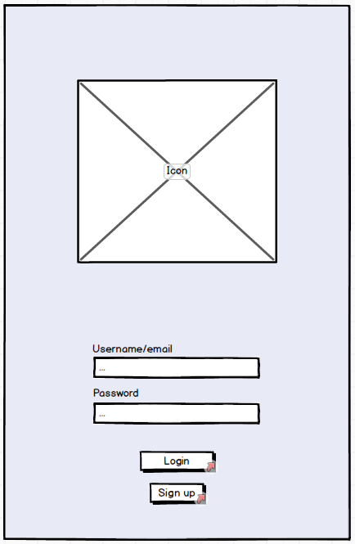

Sign up page
A page for users to sign up to Menu. Optional details include, becoming a chef and adding payment details
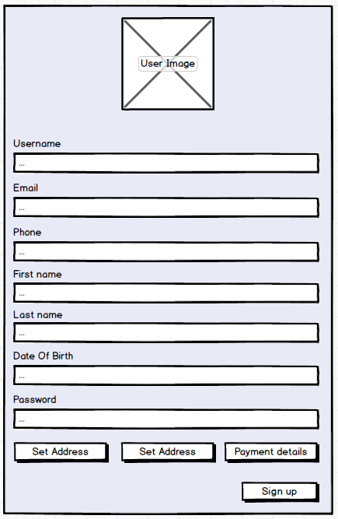

Map page
The map page acts as a hub to navigate to other pages, facilitated by the navigation drawer on the left example state of the page which navigates to:
- The chef's meal settings page (If the user is a chef)
- The settings page
- The basket page
Much of the page, as the title suggests is filled with a map displaying nearby chefs. At the top of the page is a search bar, used to search for a chef or meal. Clicking on the search icon in the search bar will navigate the user to the search results page.
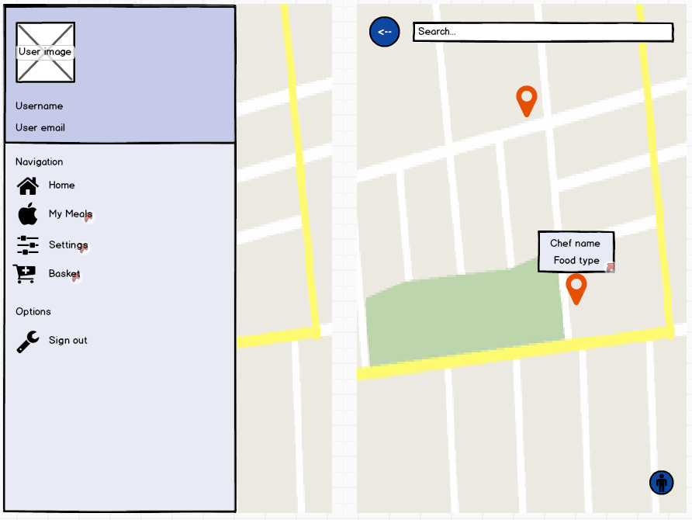

My meals page
This page will display all the meals a chef has on offer. Clicking on a meal will navigate the user to the corresponding meal page of the meal clicked on.
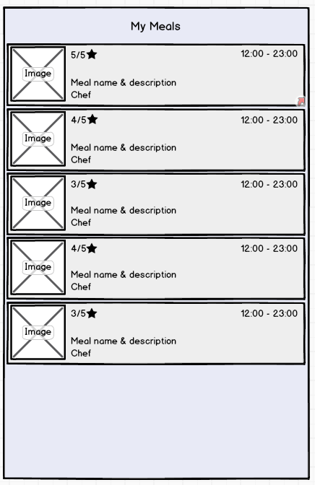

Search results page
This page will display all the meals a chef has on offer. Clicking on a meal will navigate the user to the corresponding meal page of the meal clicked on.
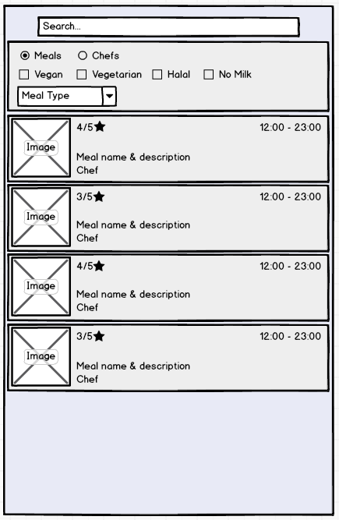

Settings page
The settings page, as the name suggested is used to enter user settings. Like the map page, it has the navigation drawer.
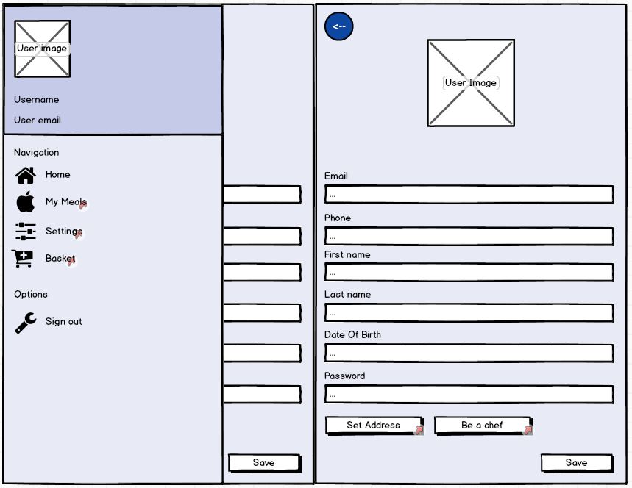

Set address page
This page will be an addon to the Settings/Sign-up page. In which the user will enter their address. Due to address inputs taking up a large proportion of space, it made sense to separate address information from other user configuration input pages.
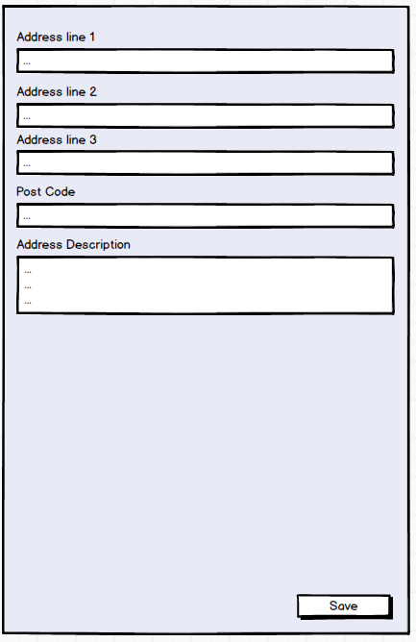

Be a chef page
This page will also be an addon to the Settings/Sign-up page, separated for the same reason as the Address settings page.
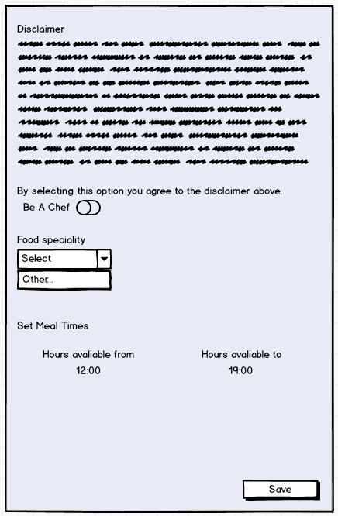

Basket
This page will display all the meals a user currently has set to order. Meals can be removed from the list if the user changes their mind, or a checkout button at the bottom of the page will allow the user to pay for their items.
Like the map page, it has the navigation drawer.
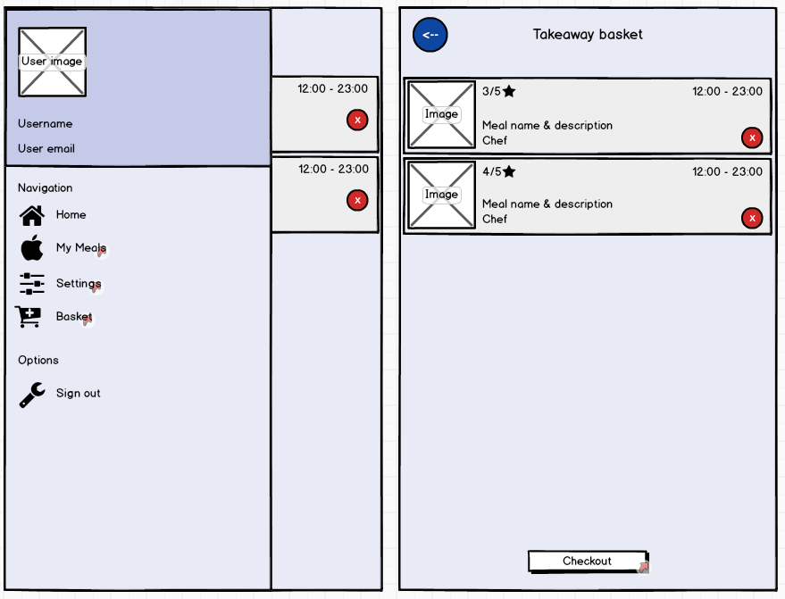

Meal View page
Displays a selected meal along with its corresponding options and information
Once order is placed user is navigated to either:
- Their basket
- The map page to continue shopping
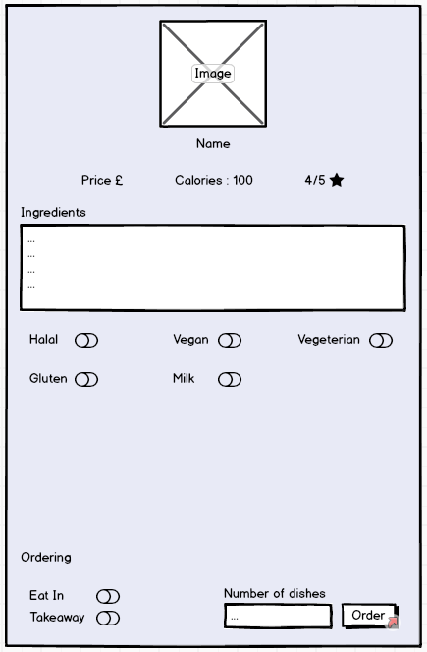

Edit meal page
This page will be used by chefs to register meals. It will also be re-used to edit meals already on sale.
Clicking the image allows the user to import an image corresponding to the meal
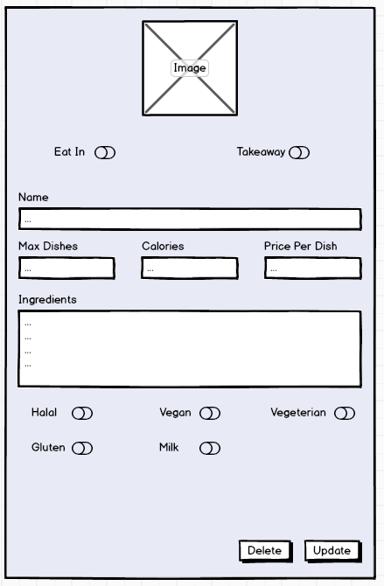

Checkout page
This page will be used to process eater’s payment for meals.
Details will either be auto filled (If the users’ details are saved) or entered in manually.
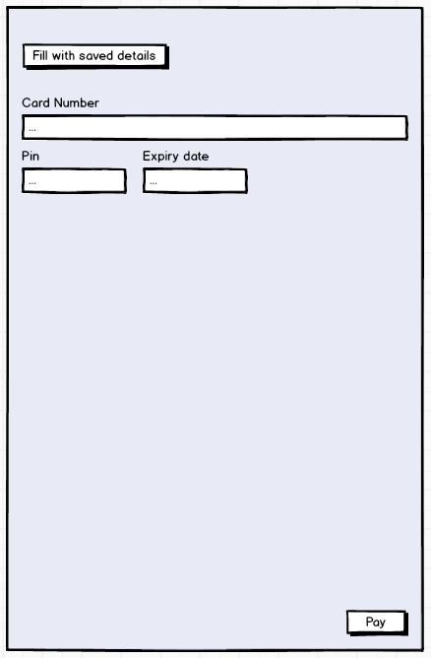

On end meal page
Once a meal has been eaten and both parties have agreed to the transaction being complete, users will be able to review each other on the meal end page. An option to report issues will also be available.
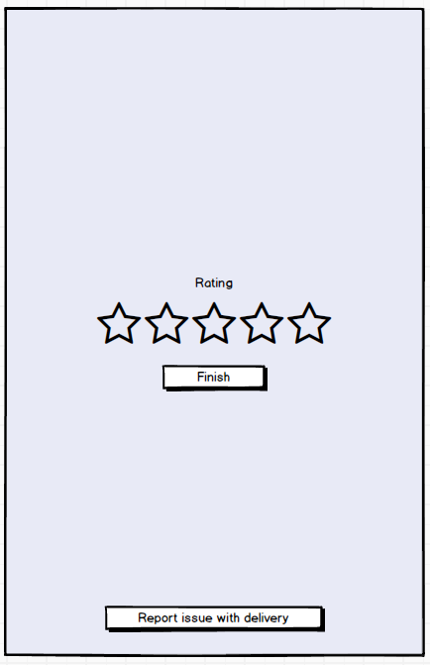

Meetup chat page
This page has multiple displays depending on the use case of its use. It provides a method of communication between users meeting chefs at their homes or chefs delivering food to users at their home. The ability to communicate allows coordination of meetups by avoiding ambiguous instructions on how to get to address, as well as notify users/chefs of delays.
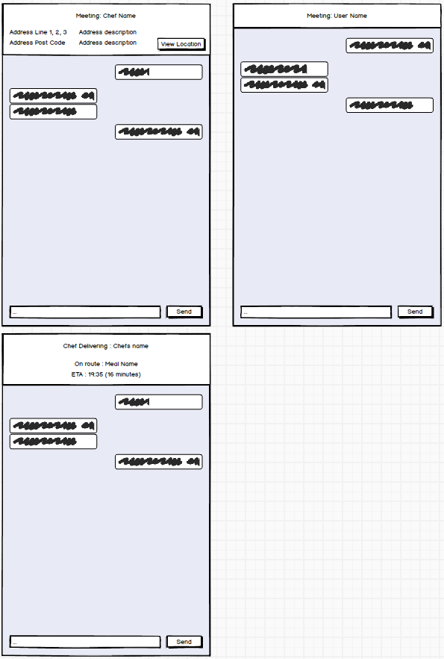
- Bibliography

Google, 2019. Material Design. [Online]
Available at: Material.io

Neitz, Maureen E. "Severity of Colorblindness Varies". Medical College of Wisconsin. 5 February 2007.
Available at: https://web.archive.org/web/20070205055320/-http://healthlink.mcw.edu/article/999211295.html

Personas images. [Online]
Available at: https://www.dreamstime.com/stock-illustration-male-female-teachers-pointer-teacher-lesson-vector-illustration-image68991182

Project smart, 2019. Moscow Method [Online]
Available at: https://www.projectsmart.co.uk/moscow-method.php

Statcounter.come, 2019. Mobile Operating System Market Share Worldwide. [Online]
Available at: https://gs.statcounter.com/os-market-share/mobile/worldwide

Statista, 2018. Just eat number of orders [Online]
Available at: https://www.statista.com/statistics/579177/just-eat-number-of-orders/

Wittig, Roman M et al. “Food sharing is linked to urinary oxytocin levels and bonding in related and unrelated wild chimpanzees.” Proceedings. Biological sciences vol. 281,1778 20133096. 15 Jan. 2014
Available at: https://www.ncbi.nlm.nih.gov/pmc/articles/PMC3906952/

The verge, 2019. There are now 2.5 billion active Android devices. [Online]
Available at: https://www.theverge.com/2019/5/7/18528297/google-io-2019-android-devices-play-store-total-number-statistic-keynote

